**Exercise - Set up a Log Analytics workspace and Azure Monitor VM Insights.**

**In this unit, we will:**

1. **Create a Log Analytics workspace.**
2. **Configure the Log Analytics workspace permissions model for the environment we're supporting.**
3. **Create two virtual machines and onboard both to Azure Monitor VM Insights.**

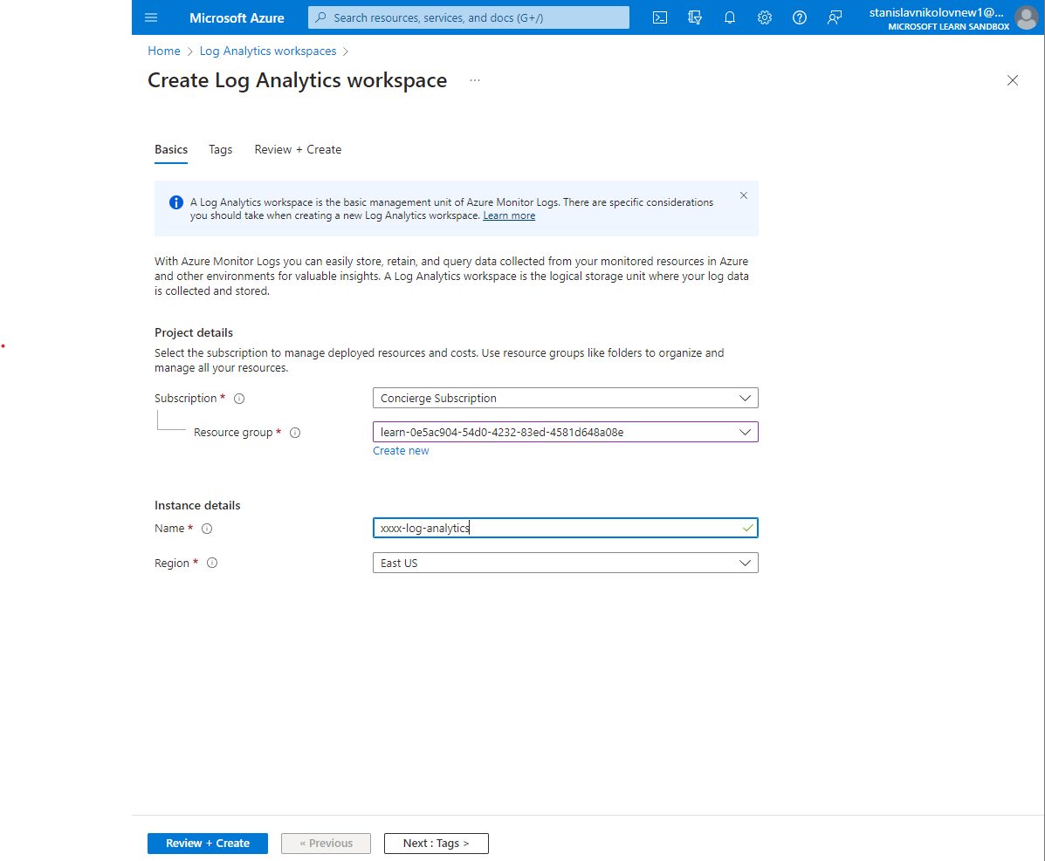

* **Creating log Analytics workspace.**

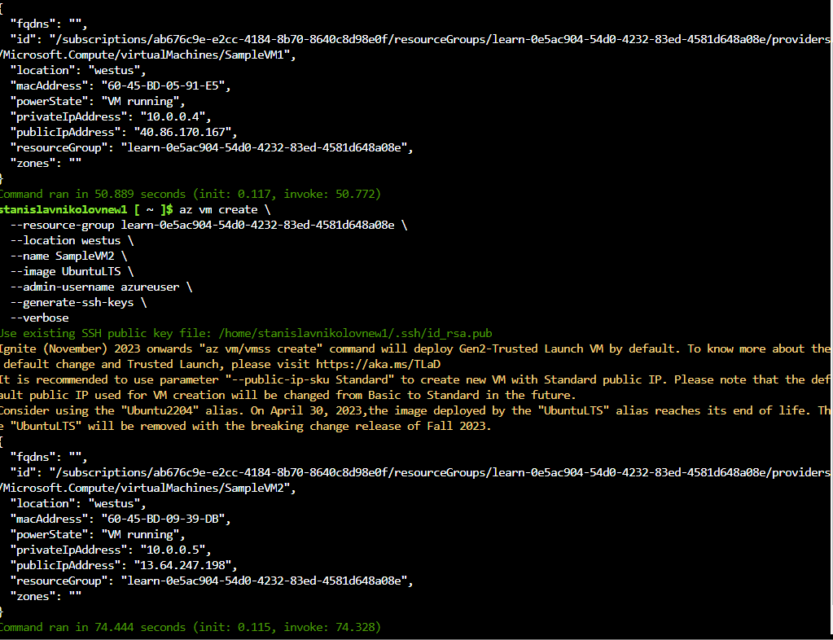

* **Setting up our environment.**
* **Onboard virtual machines to Azure Monitor VM Insights**

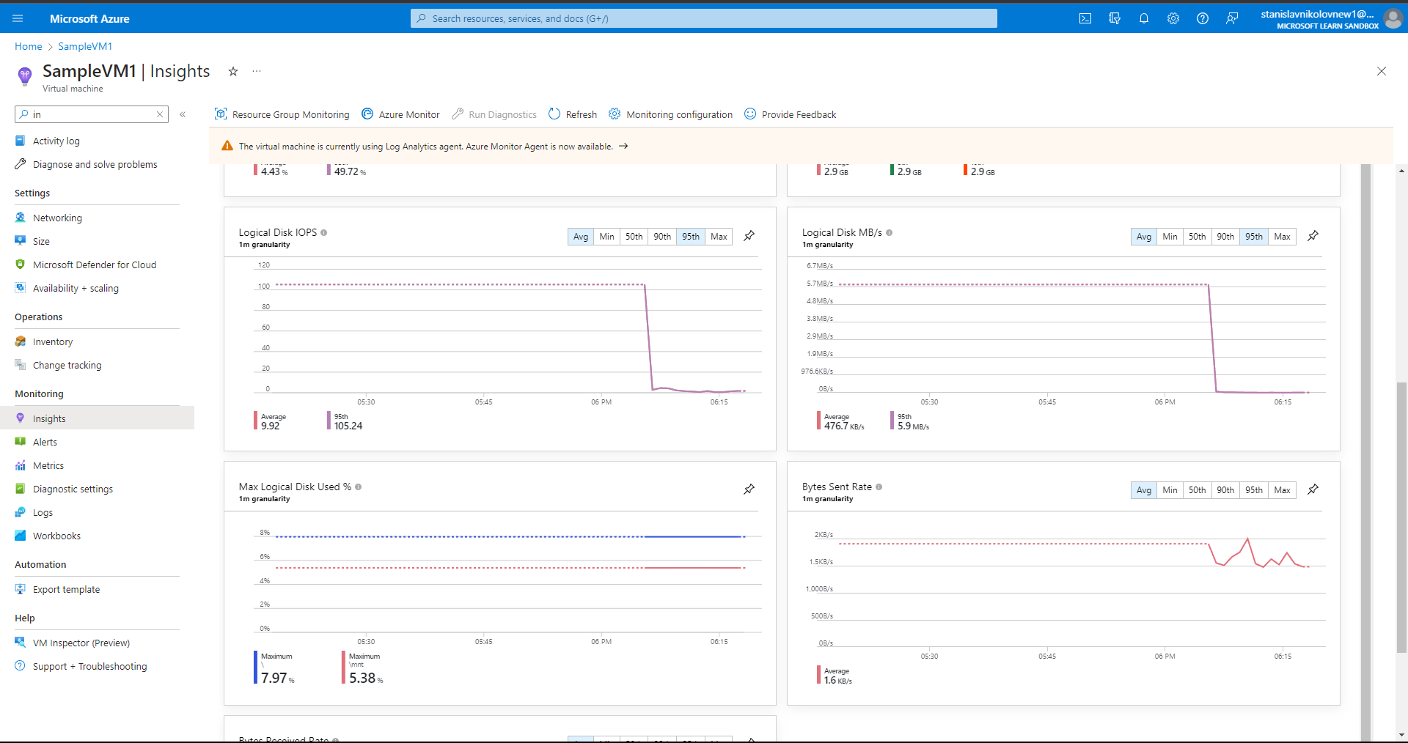

* **SampleVM1’s Performance tab**

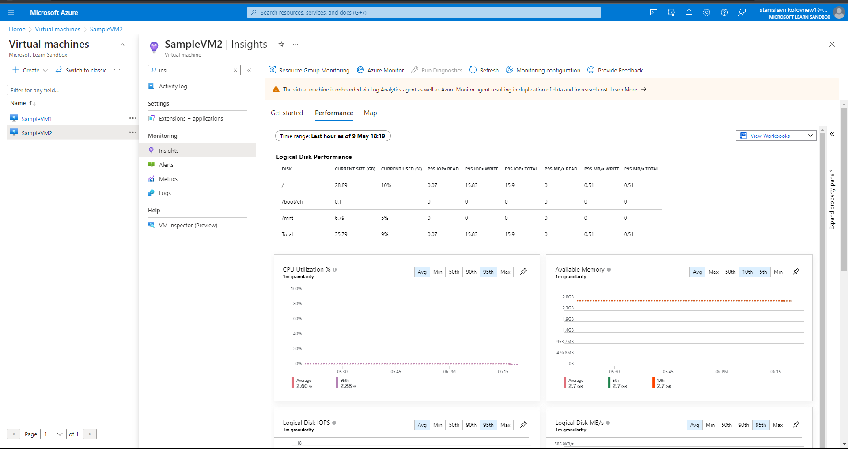

* **SampleVM2’s Performance tab.**

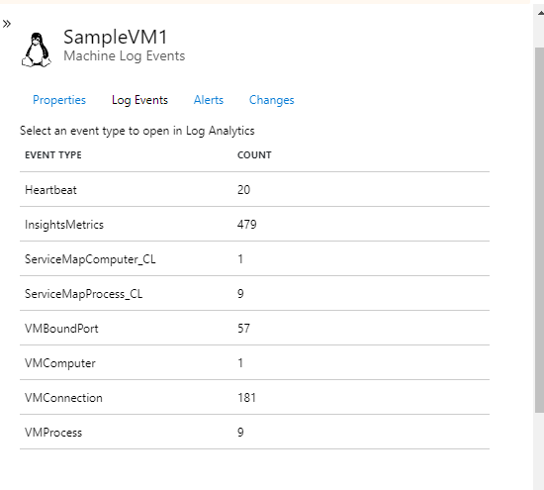

* **Selecting Log Events for SampleVM1.**

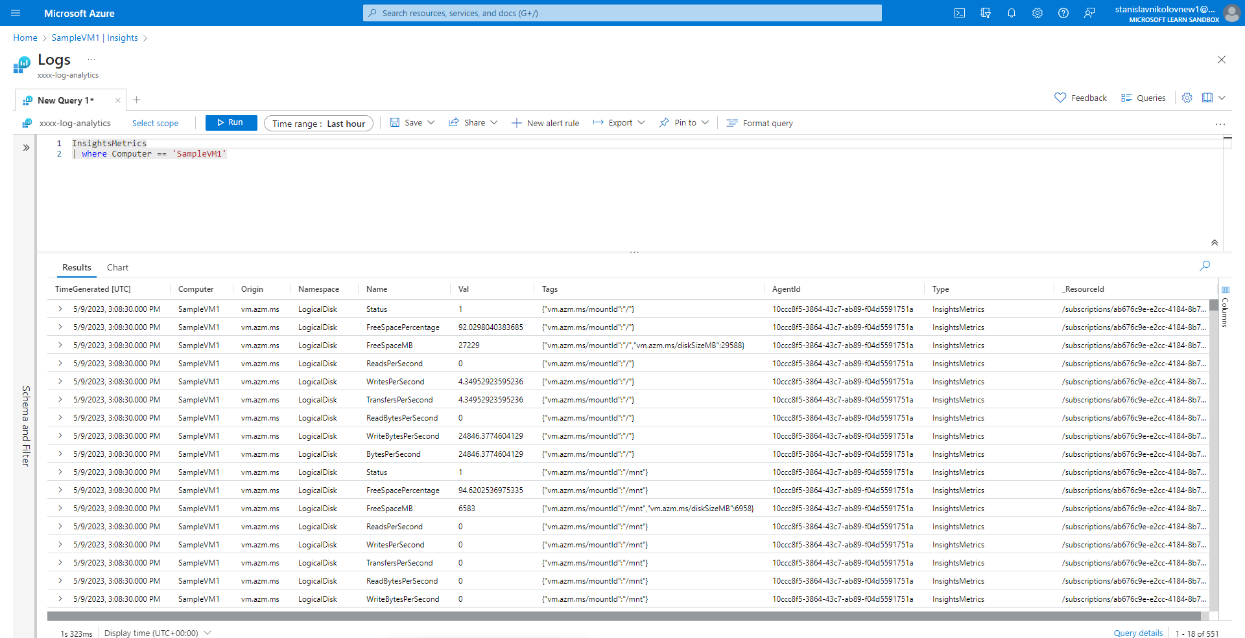

* **The logs section of a Log Analytics workspace opens with a prepopulated query showing the data being collected.**

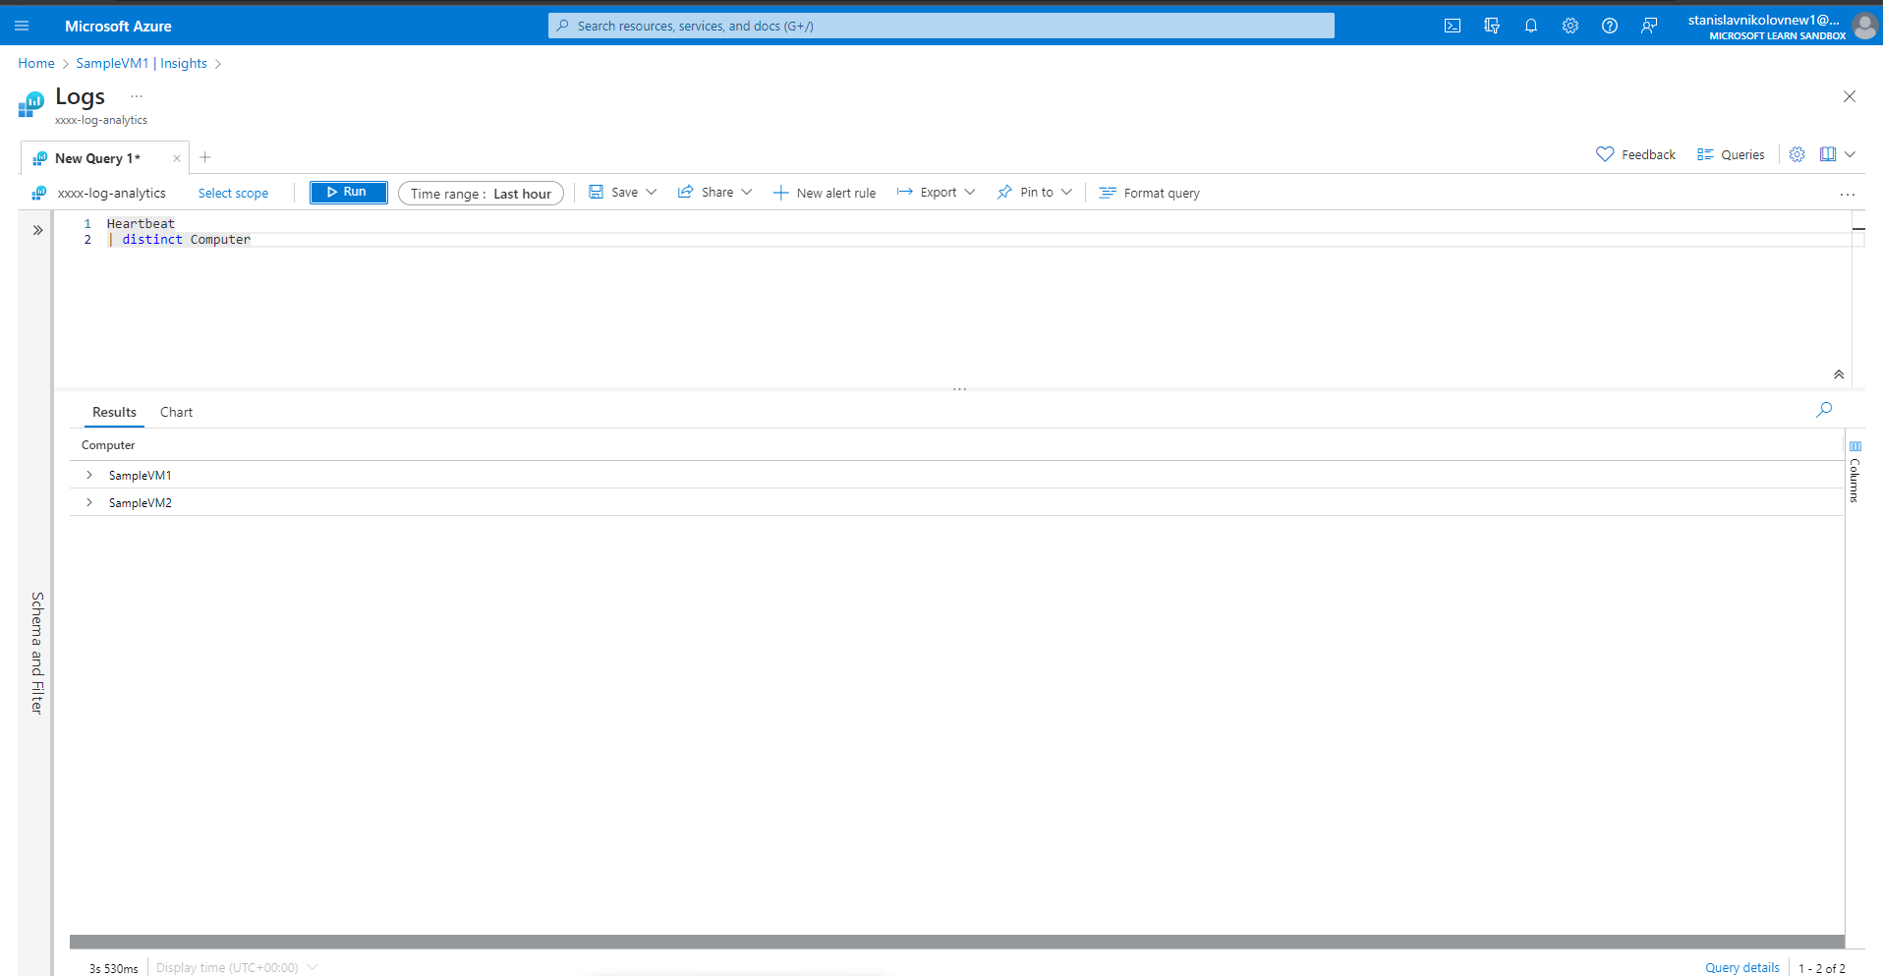

* **Building simple log queries by using the Kusto Query Language.**

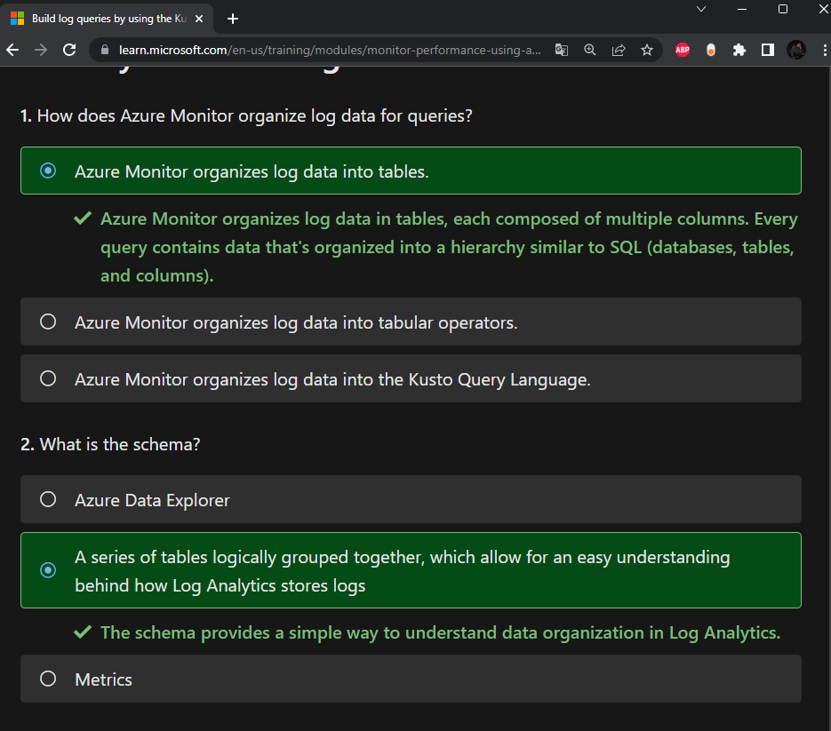

* **Final Quiz.**